# Self Assessment Monolith API Migration Plan

Author: Toby Porter

Date: 29 Jul 2020

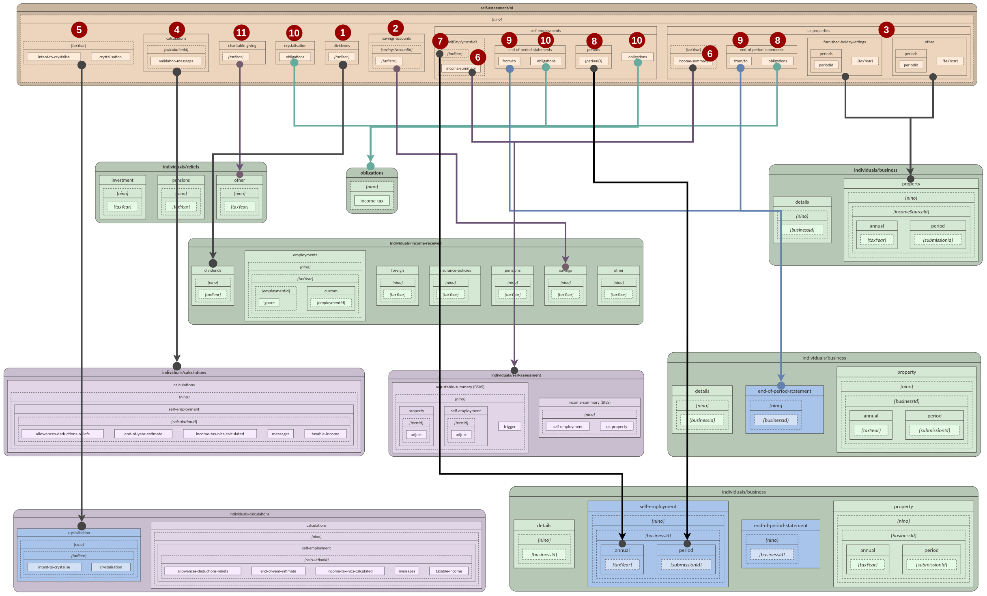

## High Level Migration Plan Summary

Monolith basepath: self-assessment/ni/{nino}

|  |  |  |  |  |
| --- | --- | --- | --- | --- |
| **Domain** | **Source Path(s)** | **Status** | **Transformation(s)** | **Destination Path(s)** |
| 1. Dividends | ●dividends/{taxYear} | P | Add 1 KVP to request body  DES to add to API#000 | ●/individuals/income-received/dividends/{nino}/{taxYear} |
| 2. Savings | ●savings-accounts/{savingsAccountId}/{taxYear} | P | #TODO | ●/individuals/income-received/savings/{nino}/{taxYear} |
| 3. Property (UK Annual) | ●uk-properties/other/{taxYear}  ●uk-properties/furnished-holiday-lettings/{taxYear} | P | Add objects for Other UK property & FHL to request body | ●/individuals/business/property/{nino}/{businessId}/annual/{taxYear} |
| Property (UK Periodic) | ●uk-properties/other/periods  ●uk-properties/furnished-holiday-lettings/periods | P | Add objects for Other UK property & FHL to request body | ●/individuals/business/property/{nino}/{businessId}/period/ |
| 4. Calculations | ●calculations | L | N/A - already live.  3PVs advised to use new APIs | ●/individuals/calculations/{nino}/self-employment |
| 5. Crystalisation | ●{taxYear}/intent-to-crystalise  ●{taxYear}/crystalisation | P | Relocate published service to new endpoints in Calculations microservice.  No impact on downstream systems | ●/individuals/calculations/crystalisation/{nino}/{taxYear}/intent-to-crystalise  ●/individuals/calculations/crystalisation/{nino}/{taxYear}/crystalisation |
| 6. Income Summary | ●self-employments/{selfEmploymentId}/{taxYear}/income-summary  ●uk-properties/{selfEmploymentId}/{taxYear}/income-summary | L | N/A - already live  3PVs advised to use new APIs | ●/individuals/self-assessment/income-summary/{nino}/self-employment  ●/individuals/self-assessment/income-summary/{nino}/uk-property |
| 7. Income (Annual) | ●self-employments/{taxYear} | P | Relocate published service to new endpoints in Business microservice.  No impact on downstream systems | ●individuals/business/self-employment/{nino}/{businessId}/annual/{taxYear} |
| 8. Income (Periodic) | ●self-employments/periods | P | Relocate published service to new endpoints in Business microservice.  No impact on downstream systems | ●individuals/business/self-employment/{nino}/{businessId}/period/ |
| 9. EOPs | ●self-employments/end-of-period-statements  ●uk-properties/end-of-period-statements | P | Consolidate 2 legacy endpoints into 1 new endpoint in Business microservice.  No impact on downstream systems | ●/individuals/business/end-of-period-statement/{nino}/{businessId} |
| 10. Obligations | ●crystalisation/obligations  ●self-employments/{selfEmploymentId}/end-of-period-statements/obligations  ●self-employments/obligations  ●uk-properties/end-of-period-statements/obligations | D | Consolidate 4 legacy endpoints into 1 new Obligations microservice. | ●/obligations/{nino}/income-tax |
| 11. Charitable Giving | charitable-giving/{taxYear} | P | Add 1 object for Charitable Giving to request body | ●/individuals/reliefs/other/{nino}/{taxYear} |

KVP = Key Value Pair | 3PV = Third Party Vendor | Status: P = Proposed; L = Live; D = In development

### Dividends

**Endpoints**

|  |  |  |  |
| --- | --- | --- | --- |
| **Source Path(s)**  /self-assessment/ni/{nino} | **Src. Method** | **Destination Path(s)** | **Dest. Method** |
| /dividends/{taxYear} | GET | /individuals/income-received/dividends/{nino}/{taxYear} | GET |
| /dividends/{taxYear} | PUT | /individuals/income-received/dividends/{nino}/{taxYear} | PUT |
|  |  | /individuals/income-received/dividends/{nino}/{taxYear} | DELETE |

**Request/Response**

|  |  |
| --- | --- |
| **Source Request** | **Destination Request** |
| {  "ukDividends": 1000.50,  "otherUkDividends": 2000.35  } | {  "foreignDividend": [  {  "countryCode": "GER",  "amountBeforeTax": 1232.22,  "taxTakenOff": 22.22,  "specialWitholdingTax": 22.22,  "foreignTaxCreditRelief": true,  "taxableAmount": 2321.22  }  ],  "dividendIncomeReceivedWhilstAbroad": [  {  "countryCode": "GER",  "amountBeforeTax": 1232.22,  "taxTakenOff": 22.22,  "specialWitholdingTax": 22.22,  "foreignTaxCreditRelief": true,  "taxableAmount": 2321.22  }  ],  "stockDividend": {  "customerReference": "my divs",  "grossAmount": 12321.22  },  "redeemableShares": {  "customerReference": "my shares",  "grossAmount": 12321.22  },  "bonusIssuesOfSecurities": {  "customerReference": "my secs",  "grossAmount": 12321.22  },  "closeCompanyLoansWrittenOff": {  "customerReference": "write off",  "grossAmount": 12321.22  },  "ukDividends": {  "grossAmount": 1000.50  },  "otherUkDividends" {  "grossAmount": 2000.35  }  } |

**End to End**

**DES**

**ITSD**

**ETMP**

**IBD**

### Savings

**Endpoints**

|  |  |  |  |
| --- | --- | --- | --- |
| **Source Path(s)**  /self-assessment/ni/{nino} | **Src. Method** | **Destination Path(s)** | **Dest. Method** |
| /savings-accounts | POST | /individuals/income-received/savings/{nino}/{taxYear} | GET |
| /savings-accounts | GET | /individuals/income-received/savings/{nino}/{taxYear} |  |
| /savings-accounts/{savingsAccountId} | GET | /individuals/income-received/savings/{nino}/{taxYear} | PUT |
| /savings-accounts/{savingsAccountId}/{taxYear} |  | /individuals/income-received/savings/{nino}/{taxYear} | DELETE |

**Request/Response**

|  |  |
| --- | --- |
| **Source Request(s)** | **Destination Request(s)** |
| {  "savingsAccounts": [  {  "id": "SAVKB2UVwUTBQGJ",  "accountName": "Main account name"  },  {  "id": "SAVKB2UVwUTBQGK",  "accountName": "Shares savings account"  }  ]  }  {  "taxedUkInterest": 1230.55,  "untaxedUkInterest": 500.5  } | {  "securities":  {  "taxTakenOff": 100.0,  "grossAmount": 1455.0,  "netAmount": 123.22  },  "foreignInterest": [  {  "amountBeforeTax": 1232.22,  "countryCode": "GER",  "taxTakenOff": 22.22,  "specialWitholdingTax": 22.22,  "taxableAmount": 2321.22,  "foreignTaxCreditRelief": true  }  ],  "savingsAccounts":  {  "taxTakenOff": 100.0,  "grossAmount": 1455.0,  "netAmount": 123.22  },  }  {  "taxedUkInterest": 1230.55,  "untaxedUkInterest": 500.5  } |
|  |  |

**End to End**

**DES**

**ITSD**

**ETMP**

**IBD**

### Property (UK Annual)

### Property (UK Periodic)

### Calculations

### Crystalisation

### Income Summary

### Income (Annual)

### Income (Periodic)

### EOPs

### Obligations

### Charitable Giving

## Issues

* No EOPs for foreign property
* Business ID not currently mandatory for UK property8
* TXM Implications